Cluster upgrade in Kubernetes
What is Upgrade in Kubernetes?
Upgrade means updating Kubernetes from an old version to a new version so you get:
- new features
- bug fixes
- security updates
- better performance
Example:
Upgrading Kubernetes version:
v1.26 → v1.27 → v1.28
Simple Definition
Kubernetes Upgrade = Process of moving the cluster from an old version to a new version safely without downtime.
First we can do cordon the node:
(MASTERNODE UPGRADE)
kubecrl get no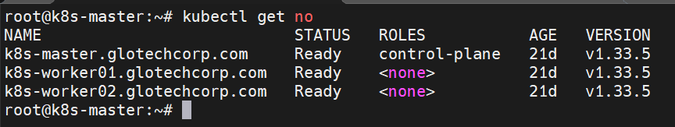
kubectl cordon master
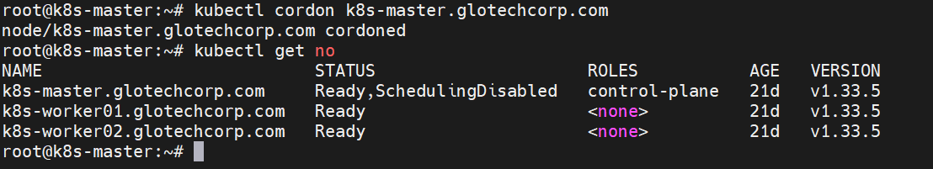
kubectl drain master --ignore-daemonsets --delete-emptydir-data 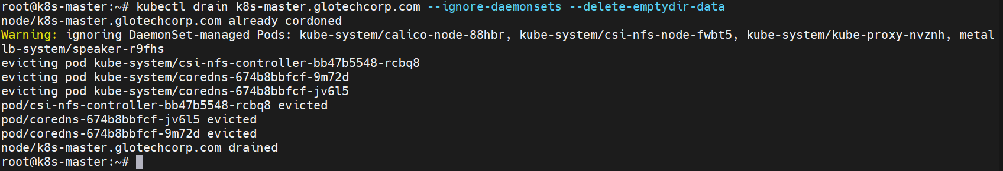
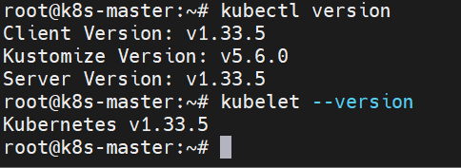
Upgrade 1.33.6
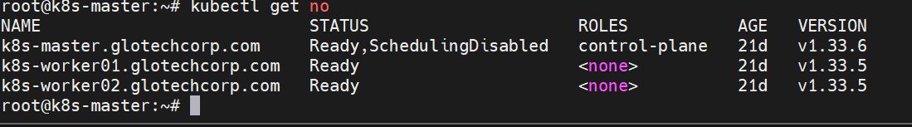
kubectl uncordon master
kubectl get node
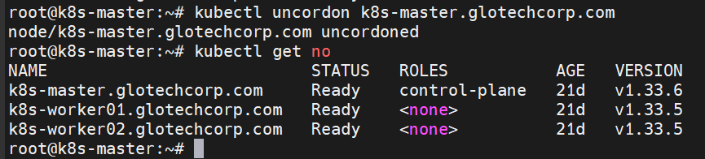
(WORKERNODE01 UPGRADE)
Masternode:
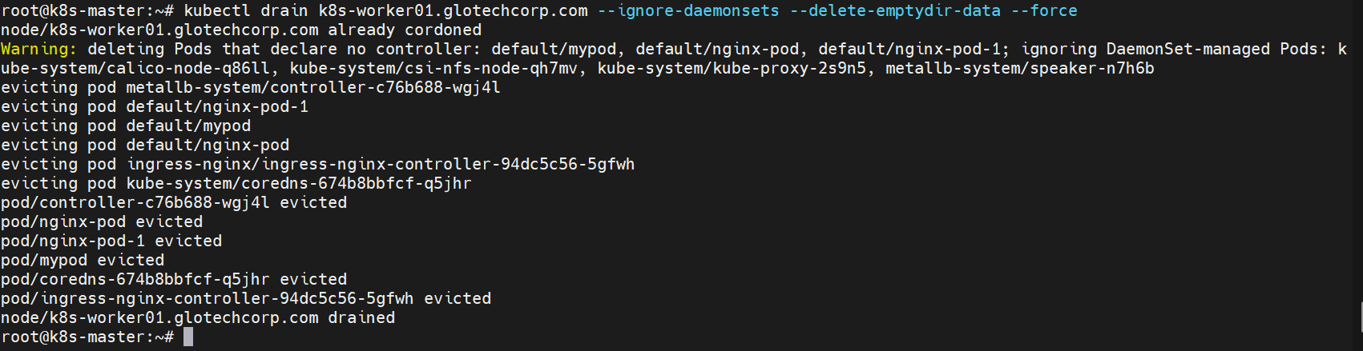
Workernode01
apt update
apt-cache madison kubeadm
apt-get install -y kubeadm kubelet kubectl
apt-get install -y kubeadm='1.33.3-1.1' kubelet='1.33.3-1.1*' kubectl='1.33.3-1.1'

before
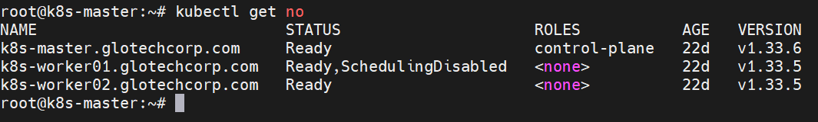
After upgrade
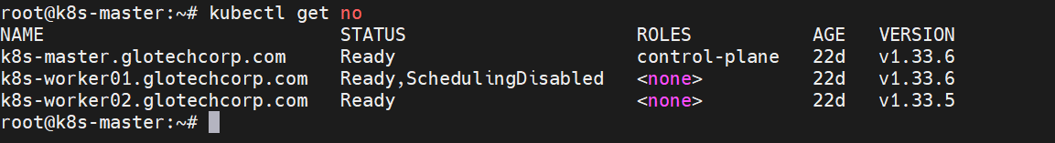
kubeadm upgrade node
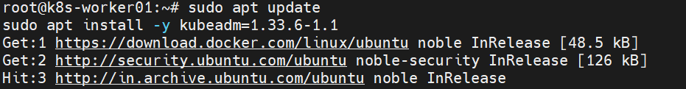
systemctl daemon-reload
systemctl restart kubelet
master
kubectl uncordon k8s-worker01.glotechcorp.com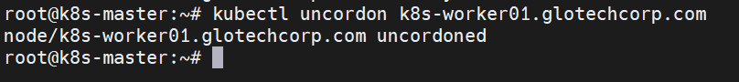
kubectl get node
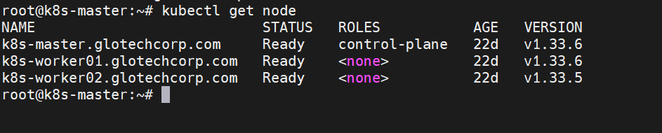
(WORKERNODE02 UPGRADE)
master
kubectl corden k8s-worker02.glotechcorp.com
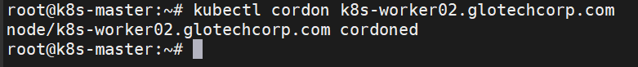
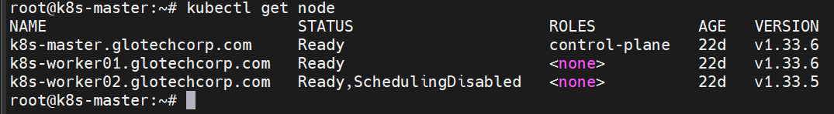
kubectl drain k8s-worker02.glotechcorp.com --ignore-daemonsets --delete-emptydir-data
worker
apt update
apt-cache madison kubeadm kubelet kubectl
apt-get install -y kubeadm kubelet kubectl
apt-get install -y kubeadm='1.33.3-1.1 ' kubelet='1.33.3-1.1*' kubectl='1.33.3-1.1'
before 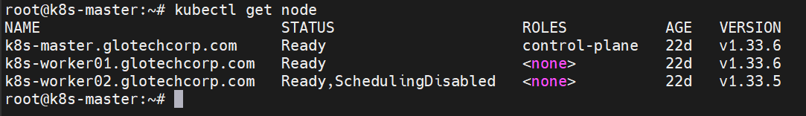
after upgrade
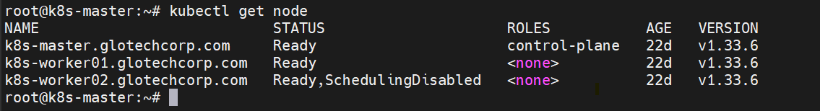
kubeadm upgrade node
systemctl daemon-reload
systemctl restart kubelet

master
kubectl uncordon k8s-worker02.glotechcorp.com
kubectl get node
